Read about Indian tribal governments in the state of Washington:
Tribal govts today - LWV chp 6.pdf Chapter 6 in the publication The State We’re In: Washington. Your guide to state, tribal and local government by the League of Women Voters of Washington Education Fund.
1. Where do you live? Whose land was it before non-Indian settlers began arriving?
2. Can you identify the modern Indian tribe that is the successor to that original owner?
3. Where is that Tribe located from where you live? Have you ever been to their reservation?
4. Check out their website - what services and resources do they provide to their community? What political issues are they actively engages in or concerned about at local, state or federal levels?
5. How can you be an ally to local Indian tribal communities in helping to ensure their rights of self-determination on issues they care about are respected?
_____________________________________________________________________________________
This map shows the location of Tribes and their reservation lands in Washington state today.
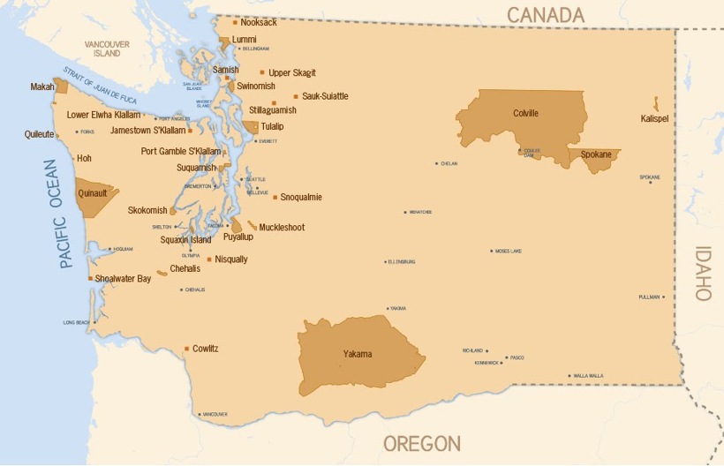
The map below shows the original land areas belonging to Tribes of Washington which were ceded (transferred) to the United States by treaty or by executive order. The darker brown areas are the land areas still retained by the Tribes as reservation lands. For a sharper image and more detailed interactive version of this map, open: TribaForlAndCededLands_8x11.pdf .

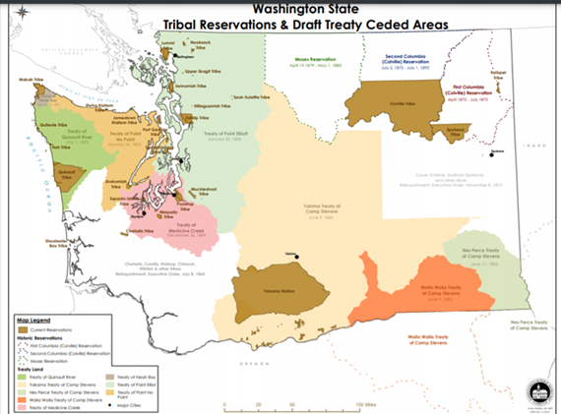

Below: Chief Moses (seated at left) of the Sin-kah-you people of north-central Washington, on a mission to Washington DC to petition President Rutherford Hayes for what became the short-lived Moses Reservation (see map). For a brief history of Chief Moses and his efforts to preserve his people's homeland, see https://www.historylink.org/File/8870. At right is a map showing traditional territory of different tribal groups in eastern Washington prior to treaty signing.
