Tribal Governments in Washington State
Read about Indian tribal governments in the state of Washington: Tribal govts today - LWV chp 6.pdf, chapter 6 from the publication The State We’re In: Washington. Your guide to state,tribal and local government by the League of Women Voters of Washington Education Fund.
Tribes around Lake Washington east of present-day Seattle.
The document at this link traces the historic Native places and names in the Lake WA region: https://www.kirklandwa.gov/files/sharedassets/public/city-managers-office/pdfs/kirkland-its-native-american-past-and-present-by-david-buerge.pdfLinks to an external site.
This map below shows the location of Tribes and their reservation lands in Washington state today.
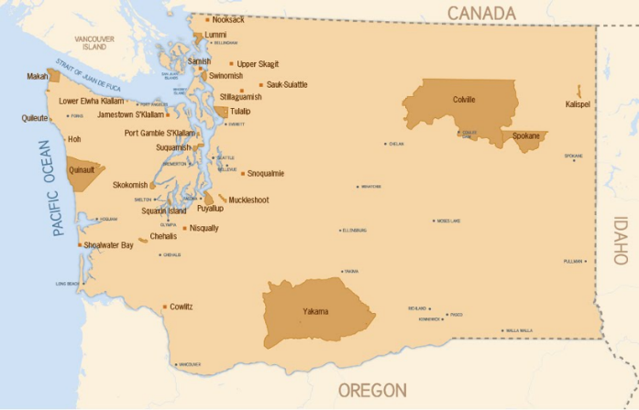
For a sharper image and more detailed interactive version of this map, open: https://goia.wa.gov/sites/default/files/public/tribal-gov/Tribal_Cedres.pdf.

Tribal lands ceded by treaty. The map below shows the original land areas belonging to Tribes of Washington which were ceded (transferred) to the United States by treaty or by executive order. The darker brown areas are the land areas still retained by the Tribes as reservation lands. https://www.k12.wa.us/sites/default/files/public/indianed/tribalsovereignty/elementary/map-treatycededareas.pdf
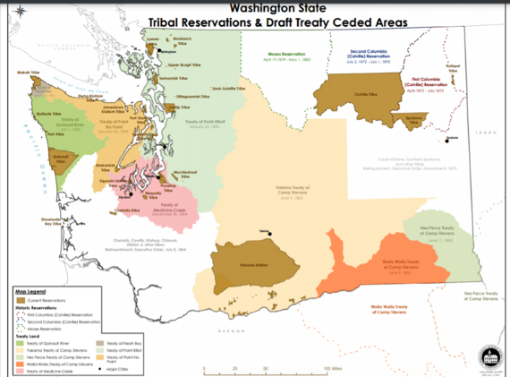
Below: Chief Moses (seated at left) of the Sin-kah-you people of north-central Washington, on a mission to Washington DC to petition President Rutherford Hayes for what became the short-lived Moses Reservation. See map of the aboriginal territories (pre-1900) of the 12 Confederated Bands of the Colville Reservation, at https://www.cct-hsy.com/demographics.

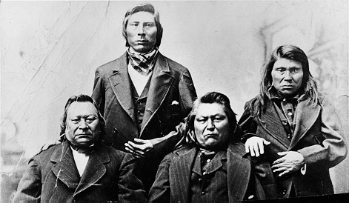
Photo source: https://commons.wikimedia.org/wiki/File:Chief_Moses_et_al.jpg.

For a brief history of Chief Moses and his efforts to preserve his people's homeland, see https://www.historylink.org/File/8870Links to an external site.

