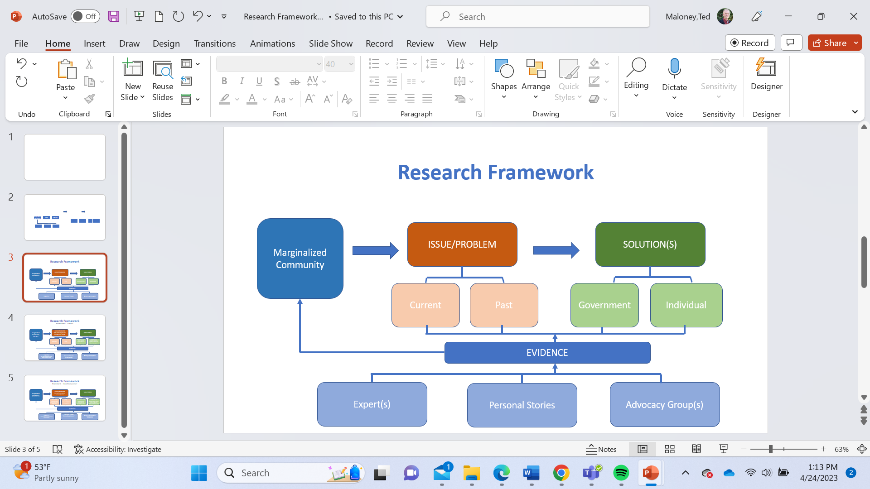
RESEARCH FRAMEWORK
- Identify Marginalized Community (evidence)
- What is an Issue/Problem adversely affecting this Community now? How is it a systemic problem?
  - Is it a Current Issue? (within past 2-5 years: evidence)
  - How is the issue connected to Past events? (historical evidence of Issue origins, continuing to present time)
- What are possible Solutions to resolve this Issue more favorably to the Marginalized Community? (search for systemic solutions for maximum impact)
  - What actions can government (federal) take to help provide a Solution? (evidence)
  - What actions can individuals (members of the public) take as allies to support/promote this Solution? (evidence)
- EVIDENCE may be from any or all of the following, found in credible sources, and supporting one or all of the above (Nos. 1-3)
  - Experts (scholars, studies, government officials, non-profit groups)
  - Advocacy Groups (from within the Marginalized Community or allied with them)
  - Personal Stories (individuals from the Marginalized Community and how this issue affects them or might be resolved to help them)

EXAMPLE NO. 1

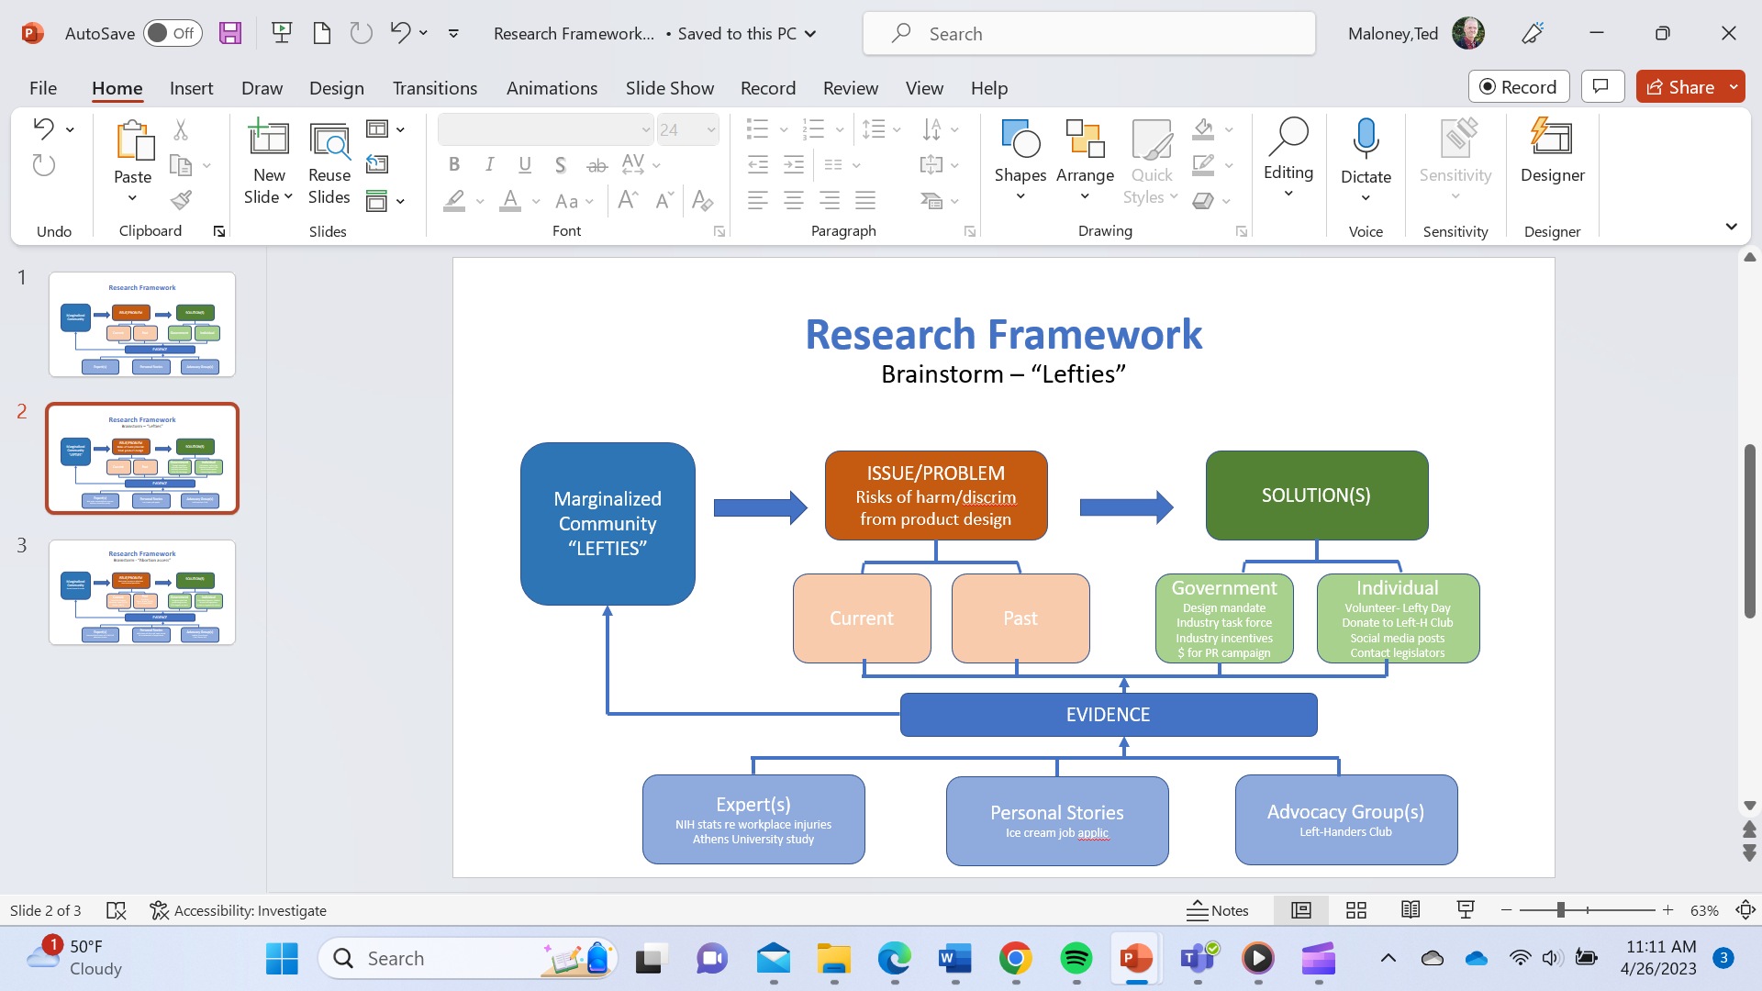

EXAMPLE NO. 2
