RESEARCH PROJECT AND TIMELINE
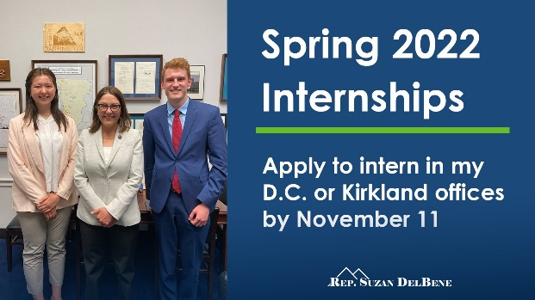
Assignment: You will assume the role of a student intern working for a government official – Member of Congress, Executive Branch department or agency, House or Senate committee, the White House (other choices are possible). In that role, you will research and write a report to your “supervisor” making recommendations for possible solutions to a current political issue affecting injustice and inequity experienced by a marginalized group within U.S. society.
RESEARCH PROJECT TIMELINE (300)
Assignment | Due Date | Points
Proposed Research Issues – top 3 | May 4 (Thursday) | 10
Annotated Bibliography | May 15 (Monday) | 10
Research Report – First Draft | May 26 (Friday) | 30
PowerPoint Upload/Replies to 3 other students | Jun 5/7 (Monday/Wednesday) | 40/20
Oral Presentations (with PowerPoint)  sign up for a time slot by Jun 2 | Jun 8 and 13 | 40
Research Report -Final Draft | Jun 14 | 150

